Paul Collado
CSC-208-60
Nov 10, 2010

ColladoCh05Page241
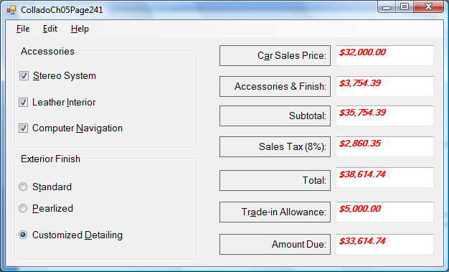

Public Class FrmColladoCh05Page241

Private Sub ExitToolStripMenuItem_Click(ByVal sender As System.Object, ByVal e As System.EventArgs) Handles ExitToolStripMenuItem.Click
Me.Close()
End Sub

Private Sub CalculateToolStripMenuItem_Click(ByVal sender As System.Object, ByVal e As System.EventArgs) Handles CalculateToolStripMenuItem.Click
Const Stero As Decimal = 425.76
Const Leather As Decimal = 987.41
Const Computer As Decimal = 1741.23
Const Pearlized As Decimal = 345.72
Const Detailing As Decimal = 599.99

Dim CarPrice As Decimal
Dim Accessories As Decimal
Dim Subtotal As Decimal
Dim SalesTax As Decimal
Dim Total As Decimal
Dim Allowance As Decimal
Dim AmountDue As Decimal

CarPrice = Val(Me.TxtCarPrice.Text)

If (ChkStereo.Checked = True) Then
Accessories = Accessories + Stero
End If

If (ChkLeather.Checked = True) Then
Accessories = Accessories + Leather
End If

If (ChkComputer.Checked = True) Then
Accessories = Accessories + Computer
End If

If (RadBtnPearlized.Checked) Then
Accessories = Accessories + Pearlized
End If

If (RadBtnDetailling.Checked) Then
Accessories = Accessories + Detailing
End If

Allowance = Val(Me.TxtTradeInAllowance.Text)

Me.TxtCarPrice.Text = FormatCurrency(CarPrice)
Me.TxtAcessoriesAndFinish.Text = FormatCurrency(Accessories)
Subtotal = Accessories + CarPrice
Me.TxtSubtotal.Text = FormatCurrency(Subtotal)
SalesTax = TaxCalculate(Subtotal)
Me.TxtTax.Text = FormatCurrency(SalesTax)
Total = Subtotal + SalesTax
Me.TxtTotal.Text = FormatCurrency(Total)
Me.TxtTradeInAllowance.Text = FormatCurrency(Allowance)
AmountDue = Total - Allowance
Me.TxtAmountDue.Text = FormatCurrency(AmountDue)
End Sub

Private Function TaxCalculate(ByVal Subtotal As Decimal) As Decimal
Const TaxRate As Decimal = 0.08
TaxCalculate = Subtotal * TaxRate
End Function

Private Sub ClearToolStripMenuItem_Click(ByVal sender As System.Object, ByVal e As System.EventArgs) Handles ClearToolStripMenuItem.Click
Me.ChkStereo.Checked = False
Me.ChkLeather.Checked = False
Me.ChkComputer.Checked = False
Me.RadBtnStandard.Checked = False
Me.RadBtnPearlized.Checked = False
Me.RadBtnDetailling.Checked = False
Me.TxtCarPrice.Clear()
Me.TxtAcessoriesAndFinish.Clear()
Me.TxtSubtotal.Clear()
Me.TxtTax.Clear()
Me.TxtTotal.Clear()
Me.TxtTradeInAllowance.Clear()
Me.TxtAmountDue.Clear()
Me.TxtCarPrice.Focus()
End Sub

Private Sub FontToolStripMenuItem_Click(ByVal sender As System.Object, ByVal e As System.EventArgs) Handles FontToolStripMenuItem.Click
Me.FontDialog1.ShowDialog()
Me.TxtCarPrice.Font = Me.FontDialog1.Font
Me.TxtAcessoriesAndFinish.Font = Me.FontDialog1.Font
Me.TxtSubtotal.Font = Me.FontDialog1.Font
Me.TxtTax.Font = Me.FontDialog1.Font
Me.TxtTotal.Font = Me.FontDialog1.Font
Me.TxtTradeInAllowance.Font = Me.FontDialog1.Font
Me.TxtAmountDue.Font = Me.FontDialog1.Font
End Sub

Private Sub ColorToolStripMenuItem_Click(ByVal sender As System.Object, ByVal e As System.EventArgs) Handles ColorToolStripMenuItem.Click
Me.ColorDialog1.ShowDialog()
Me.TxtCarPrice.ForeColor = Me.ColorDialog1.Color
Me.TxtAcessoriesAndFinish.ForeColor = Me.ColorDialog1.Color
Me.TxtSubtotal.ForeColor = Me.ColorDialog1.Color
Me.TxtTax.ForeColor = Me.ColorDialog1.Color
Me.TxtTotal.ForeColor = Me.ColorDialog1.Color
Me.TxtTradeInAllowance.ForeColor = Me.ColorDialog1.Color
Me.TxtAmountDue.ForeColor = Me.ColorDialog1.Color
End Sub

Private Sub TxtAcessoriesAndFinish_Click(ByVal sender As Object, ByVal e As System.EventArgs) Handles TxtAcessoriesAndFinish.Click
MessageBox.Show("You cannot edit this box", "Error")
Me.TxtCarPrice.Focus()
End Sub

Private Sub TxtSubtotal_Click(ByVal sender As Object, ByVal e As System.EventArgs) Handles TxtSubtotal.Click
MessageBox.Show("You cannot edit this box", "Error")
Me.TxtCarPrice.Focus()
End Sub

Private Sub TxtTax_Click(ByVal sender As Object, ByVal e As System.EventArgs) Handles TxtTax.Click
MessageBox.Show("You cannot edit this box", "Error")
Me.TxtCarPrice.Focus()
End Sub

Private Sub TxtTotal_Click(ByVal sender As Object, ByVal e As System.EventArgs) Handles TxtTotal.Click
MessageBox.Show("You cannot edit this box", "Error")
Me.TxtCarPrice.Focus()
End Sub

Private Sub TxtAmountDue_Click(ByVal sender As Object, ByVal e As System.EventArgs) Handles TxtAmountDue.Click
MessageBox.Show("You cannot edit this box", "Error")
Me.TxtCarPrice.Focus()
End Sub

Private Sub AboutToolStripMenuItem_Click(ByVal sender As System.Object, ByVal e As System.EventArgs) Handles AboutToolStripMenuItem.Click
MessageBox.Show("Program Name: ColladoCh05Page237" & vbNewLine & "Programmer Name: Paul Collado", _
"Info Box")
End Sub
End Class

